**LAB 4**

**HUB**

Hubs are networking devices operating at a physical layer of the OSI model that are used to connect multiple devices in a network. They are generally used to connect computers in a LAN.

A hub has many ports in it. A computer which intends to be connected to the network is plugged in to one of these ports. When a data frame arrives at a port, it is broadcast to every other port, without considering whether it is destined for a particular destination device or not.

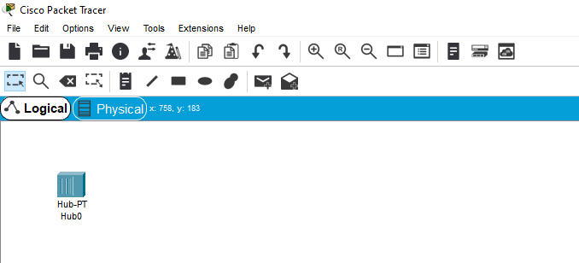

**SWITCH**

Switches are networking devices operating at layer 2 or a data link layer of the OSI model. They connect devices in a network and use packet switching to send, receive or forward data packets or data frames over the network.

A switch has many ports, to which computers are plugged in. When a data frame arrives at any port of a network switch, it examines the destination address, performs necessary checks and sends the frame to the corresponding device(s).It supports unicast, multicast as well as broadcast communications**.**

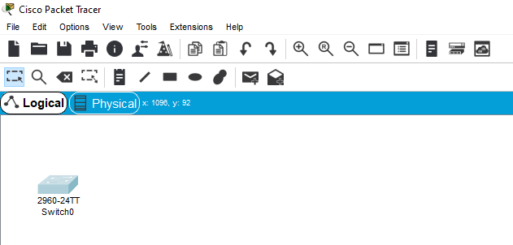

**ROUTER**

Routers are networking devices operating at layer 3 or a network layer of the OSI model. They are responsible for receiving, analysing, and forwarding data packets among the connected computer networks. When a data packet arrives, the router inspects the destination address, consults its routing tables to decide the optimal route and then transfers the pack.

The functioning of a router depends largely upon the routing table stored in it. The routing table stores the available routes for all destinations. The router consults the routing table to determine the optimal route through which the data packets can be sent.et along this route.

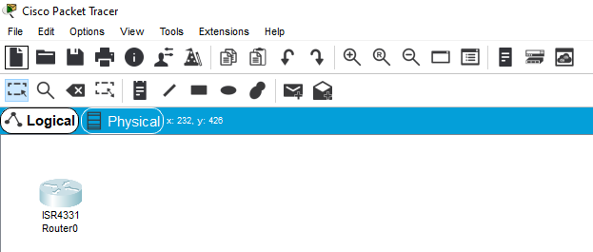

**COMPUTER SYSTEMS (NODES IN A NETWORK) AND WIRES**

A computer network consists of various kinds of nodes. Servers, networking hardware, Personal computers, and other specialized or general-purpose hosts can all be nodes in a computer network.

In networking a node is either a connection point, a redistribution point, or a communication endpoint. In computer science, nodes are devices or data points on a large network, devices such a PC, phone, or printer are considers nodes.

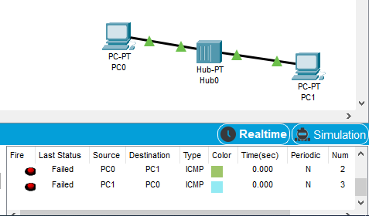

**TOPOLOGIES:-**

1. **STAR TOPOLOGY-**

* Star topology is an arrangement of the network in which every node is connected to the central hub, switch or a central computer.
* The central computer is known as a server, and the peripheral devices attached to the server are known as clients.
* Coaxial cable or RJ-45 cables are used to connect the computers.
* Hubs or Switches are mainly used as connection devices in a physical star topology.
* Star topology is the most popular topology in network implementation.

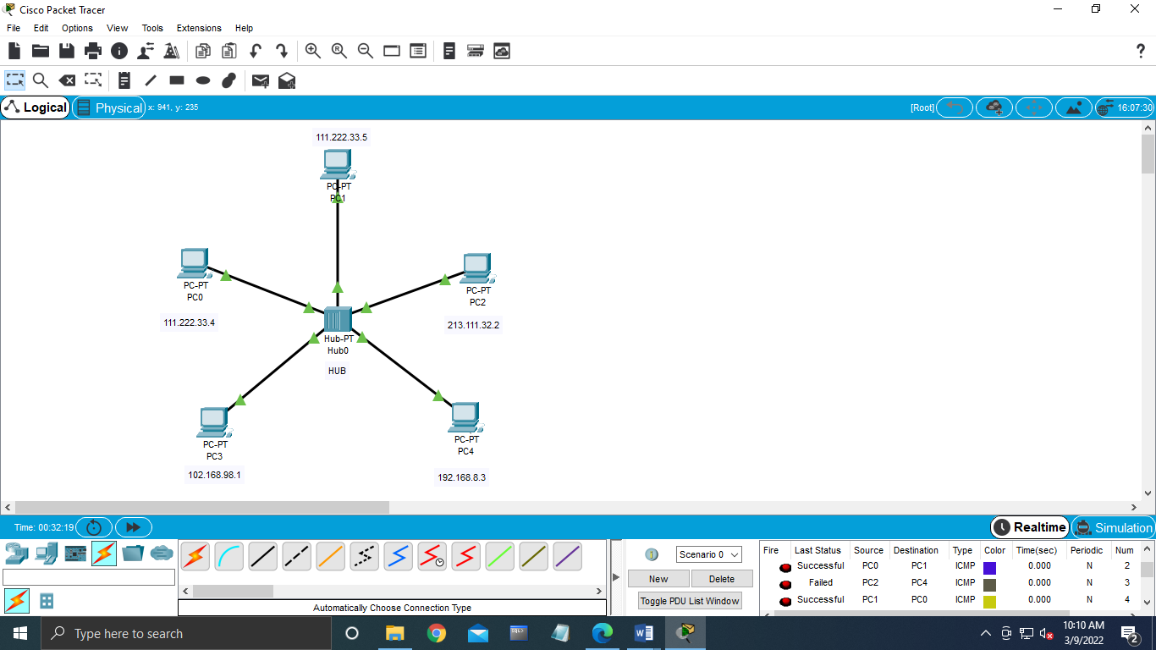

1. **RING TOPOLOGY-**

* A ring topology is a network configuration where device connections create a circular data path. Each networked device is connected to two others, like points on a circle. Together, devices in a ring topology are referred to as a ring network.
* In a ring network, packets of data travel from one device to the next until they reach their destination. Most ring topologies allow packets to travel only in one direction, called a unidirectional ring network. Others permit data to move in either direction, called bidirectional.
* The major disadvantage of a ring topology is that if any individual connection in the ring is broken, the entire network is affected.
* Ring topologies may be used in either LANs (local area networks) or WANs (wide area networks). Depending on the network card used in each computer of the ring topology, a coaxial cable or an RJ-45 network cable is used to connect computers together.

